

What’s New?

VBS

June 13-17

6-830pm

**Up NEXT**

**Sunday:**

**LIGHTconnect:** 9:45am-10:45am

**LIGHTshow Children Church**: 11am-12pm

**Wednesday LIGHTgrow**: Virtual

No Children Church on Fathers Day

Camp (August 2-5) Payment Deadline : **July 4**

* + Covid Safe Caraway Camp
  + Meeting **July 18** after church.

**July 17**: Family Summer Bash: 11-2

**July 11**: Rising 6th can begin attending Youth *see youth page on website for details*

**Children Newsletter!**

**Reflect | Discover| Grow**

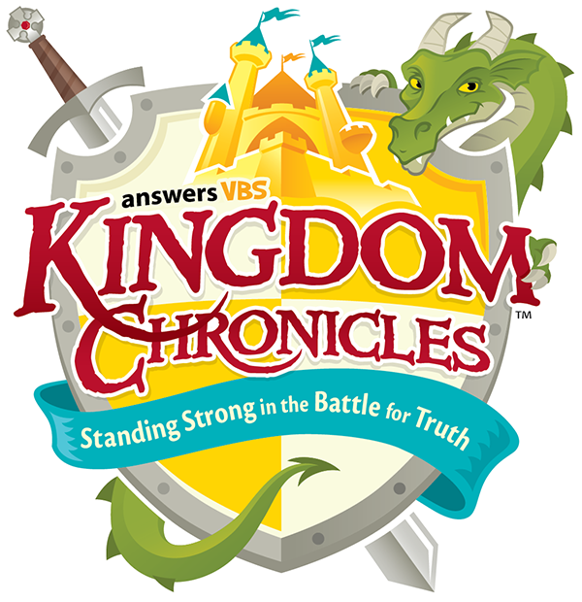

Leading your Family @ Home Resource!

RIGHTNOW MEDIA! To gain access scan this QR code. This is a free gift for your family to help grow your children at home.

A Word from the LIGHT Team.

Parents and Families,

If you have not had a chance to plug in now is the time! With the excitement of Summer and need for vacation, do not leave sacrifice Church. If you have not had a chance to meet Pastor Zach or our team, please reach out so we can connect with you! We look forward to this next season of ministry!

With much Love,

The LIGHT Team

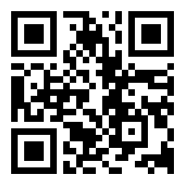

Contact:

*Pastor Zach Flannery*

*Cell: Text: 704-345-9913 or Call the Church*

*Email:* [*zach.flannery@firstbaptistlocust.com*](mailto:zach.flannery@firstbaptistlocust.com)